MC 2 Data Description

Important notes:
- All of the data is synthetic. Resemblance to real people or situations is incidental.
- Use only data from this mini challenge to answer the questions. Data may be inconsistent between challenges. No external sources are required to answer the questions posed.

The data of this challenge comes from two major sources:
- Meeting notes: Record actions in COOTEFOO public meetings. This includes a description of what was talked about, who was involved in the discussion and a general coding of sentiment that persons’ comments held.
- Travel records: Records trips taken by COOTEFOO members in their official capacity. It is derived from highway monitors, ferry stations, parking records at official lots and receipts from parking meters. This is not a complete trip report, but a partial collection.

The schema of each of these types of records is pictured below. Note that the two record types use the person and place records. It is at these records that the two record types intersect to form a single graph.

Meeting Minutes | Travel
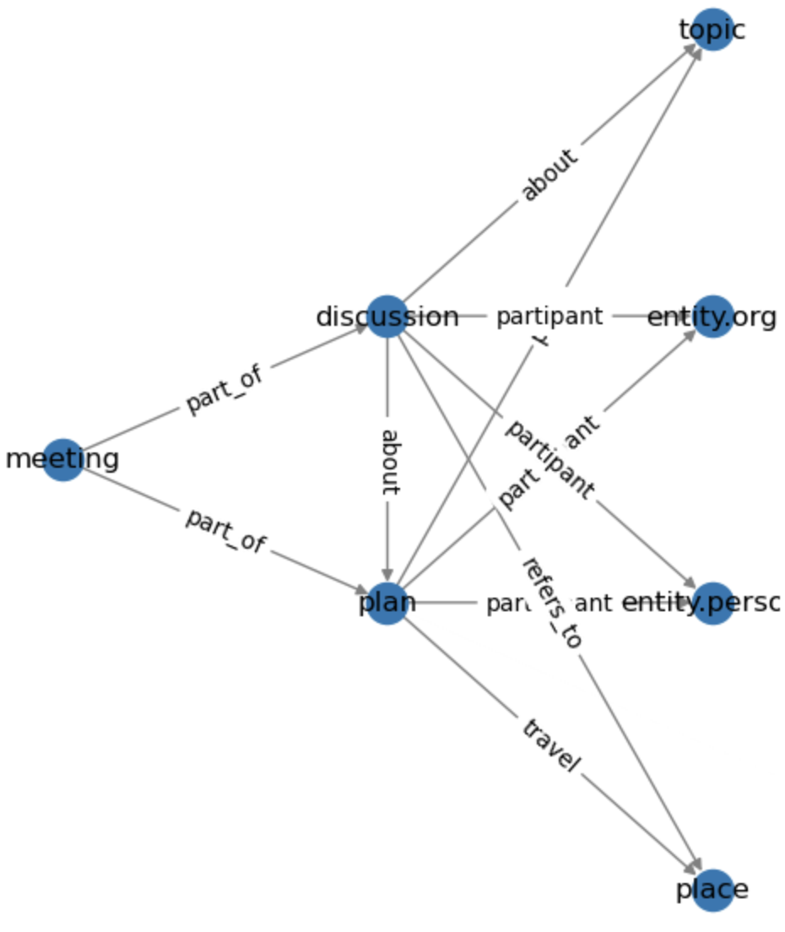 | 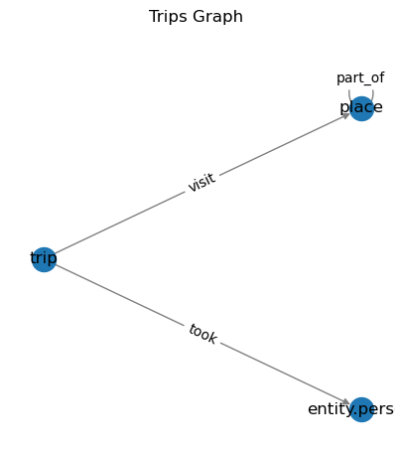

The attributes and types are as follows
 | Type | Attribute | Meaning
 | Node | place | Represents locations related to discussions and plans
 |  |  | id | Unique identifier for the place, usually an ID, sometimes the label
 |  |  | lat | Latitude of the place
 |  |  | lon | Longitude of the place
 |  |  | zone | Zone classification of the place
 |  |  | zone_detail | Specific details about the zone
 |  |  | label | Label or name of the place
 | Node | plan | Nodes representing plans
 |  |  | id | Unique identifier for the plan, short_title
 |  |  | type | Indicates the type of the node, here as plan
 |  |  | short_title | A concise title for the plan
 |  |  | long_title | Complete details of the plan title
 |  |  | plan_type | Classification of the plan (e.g. Travel)
 |  |  | label | Plan label representing its title
 | Node | discussion | Nodes representing discussions
 |  |  | id | Unique identifier for the discussion, short_title
 |  |  | type | Indicates the type of the node, here as discussion
 |  |  | short_title | A concise title for the discussion
 |  |  | long_title | Complete details of the discussion title
 |  |  | label | Discussion label representing its title
 | Node | entity.organization | Represents organizations involved in meetings or discussions
 |  |  | id | Unique identifier for the organization (name)
 | Node | meeting | Nodes representing meetings
 |  |  | id | Unique identifier for the meeting, label
 |  |  | type | Indicates the type of the node, here as meeting
 |  |  | date | Date when the meeting is scheduled
 |  |  | label | Meeting label representing its title
 | Node | entity.person | Represents people involved in the committee
 |  |  | id/name | Unique identifier for the person
 |  |  | role | Role within the committee
 |  |  | type | Indicates the type of the node, here as entity.person
 | Node | topic | Nodes representing topics
 |  |  | id | Unique identifier for the topic, short_topic
 |  |  | type | Indicates the type of the node, here as topic
 |  |  | short_topic | A concise title for the topic
 |  |  | long_topic | Complete details of the topic title
 |  |  | label | Topic label representing its title, short_topic
 | Node | trip | Nodes representing trips
 |  |  | id | Unique identifier for the trip
 |  |  | type | Indicates the type of the node, here as trip
 |  |  | date | Date when the trip is scheduled
 |  |  | start | Starting time of the trip
 |  |  | end | Ending time of the trip
 | Edge | trip to place | Indicates a trip connection to a place
 |  |  | source | Trip identifier
 |  |  | target | Place identifier or name
 |  |  | time | Time when the trip involves the place
 | Edge | trip to person | Indicates a trip connection to a person
 |  |  | source | Trip that involves the person
 |  |  | target | Person associated with the trip
 | Edge | participant (plan to person) | Indicates a person's involvement in a plan
 |  |  | source | Plan that the person is part of
 |  |  | target | Person involved in the plan
 |  |  | role | participant
 |  |  | sentiment | Sentiment or stance held by the person regarding a topic (sometimes null if no sentiment is recorded)
 |  |  | reason | Rationale behind the sentiment or stance
 |  |  | industry | Industry related to the topic
 | Edge | about (discussion to plan) | Relates discussions to plans
 |  |  | source | Discussion that relates to the plan
 |  |  | target | Plan discussed
 |  |  | role | about
 |  |  | status | Current status of the plan (e.g. planned, completed)
 | Edge | plan (plan to topic) | Associates a plan with a topic
 |  |  | source | Plan connected to the topic
 |  |  | target | Topic associated with the plan
 |  |  | role | plan
 | Edge | travel (plan to place) | Indicates travel from plan to place
 |  |  | source | Plan that involves travel
 |  |  | target | Place connected to the plan
 |  |  | role | travel
 | Edge | about (discussion to topic) | Associates a discussion with a topic
 |  |  | source | Discussion connected to the topic
 |  |  | target | Topic associated with the discussion
 |  |  | role | about
 | Edge | Part of (Meeting to discussion) | Associates a meeting with a discussion
 |  |  | source | Meeting
 |  |  | Target | Discussion
 |  |  | role | Part of
 | Edge | Part of (Meeting to plan) | Associates a meeting with a plan
 |  |  | source | Meeting
 |  |  | Target | plan
 |  |  | role | Part of
Edge |  | participant (discussion to person) | Indicates a person's involvement in a discussion
 |  |  | source | Discussion that the person is part of
 |  |  | target | Person involved in the discussion
 |  |  | role | participant
 |  |  | sentiment | Sentiment or stance held by the person regarding a topic (sometimes null if no sentiment is recorded)
 |  |  | reason | Rationale behind the sentiment or stance
 |  |  | industry | Industry related to the topic
Edge |  | Refers_to (discussion to place) | source | discussion
 |  |  | Target | place
Edge |  | participant (discussion to entity.organiztion) | Indicates a organization’s involvement in a discussion
 |  |  | source | Discussion that the organization is part of
 |  |  | target | Organization involved in the discussion
 |  |  | role | participant
 |  |  | sentiment | Sentiment or stance held by the organization regarding a topic (sometimes null if no sentiment is recorded)
 |  |  | reason | Rationale behind the sentiment or stance
 |  |  | industry | Industry related to the topic
Edge |  | participant (plan to entity.organiztion) | Indicates an organization’s involvement in a plan
 |  |  | source | Plan that the organization is part of
 |  |  | target | Organization involved in the plan
 |  |  | role | participant
 |  |  | sentiment | Sentiment or stance held by the organization regarding a topic (sometimes null if no sentiment is recorded)
 |  |  | reason | Rationale behind the sentiment or stance
 |  |  | industry | Industry related to the topic

These records have been combined in various ways into knowledge graphs:
- FiLAH.json
- TROUT.json
- journalist.json
The FILAH.json and TROUT.json graphs are subsets of the journalist graph, represent the data subsets that those two organizations collected.
In addition to the data described above, there is a road map of Oceanus and a geographic map. These are not required to solve the challenge but may be useful for contextualizing results. The road map is road_map.json and is formatted as a graph similar to those described above. The X/Y coordinates correspond to the longitude and latitude. The oceanus_map.geojson is formatted as a geojson file and was created using goepandas and shapely python libraries.

